Immunology
Lecture -1-
History of immunology
Immunology is a science that examines the structure and function of the immune system. It originates from medicine and early studies on the causes of immunity to disease. The earliest known reference to immunity was during the plague of Athens in 430 BC. Thucydides noted that people who had recovered from a previous bout of the disease could nurse the sick without contracting the illness a second time. In the 18th century, Pierre-Louis Moreau de Maupertuis made experiments with scorpion venom and observed that certain dogs and mice were immune to this venom. This and other observations of acquired immunity were later exploited by Louis Pasteur in his development of vaccination and his proposed germ theory of disease. Pasteur's theory was in direct opposition to contemporary theories of disease, such as the miasma theory. It was not until Robert Koch's 1891 proofs, for which he was awarded a Nobel Prize in 1905, that microorganisms were confirmed as the cause of infectious disease. Viruses were confirmed as human pathogens in 1901, with the discovery of the yellow fever virus by Walter Reed . Immunology made a great advance towards the end of the 19th century, through rapid developments, in the study of humoral immunity and cellular immunity. Particularly important was the work of Paul Ehrlich, who proposed the side-chain theory to explain the specificity of the antigen-antibody reaction; his contributions to the understanding of humoral immunity were recognized by the award of a Nobel Prize in 1908, which was jointly awarded to the founder of cellular immunology.
The immune system protects organisms from infection with layered defenses of increasing specificity. In simple terms, physical barriers prevent pathogens such as bacteria and viruses from entering the organism. If a pathogen breaches these barriers, the innate immune system provides an immediate, but non-specific response. Innate immune systems are found in all plants and animals. If pathogens successfully evade the innate response, vertebrates possess a second layer of protection, the adaptive immune system, which is activated by the innate response. Here, the immune system adapts its response during an infection to improve its recognition of the pathogen. This improved response is then retained after the pathogen has been eliminated, in the form of an immunological memory, and allows the adaptive immune system to mount faster and stronger attacks each time this pathogen is encountered. Both innate and adaptive immunity depend on the ability of the immune system to distinguish between self and non-self molecules. In immunology, self molecules are those components of an organism's body that can be distinguished from foreign substances by the immune system. Conversely, non-self molecules are those recognized as foreign molecules. One class of non-self molecules are called antigens (short for antibody generators) and are defined as substances that bind to specific immune receptors and elicit an immune response .

IMMUNOLOGY
Lecture : 2 Important Terms
A: Antigen (Ag)
A substance that reacts with the products of a specific immune response.
B : Immunogen
A substance that induces a specific immune response .
C : Hapten
A substance that is non-immunogenic but which can react with the products of a specific immune response. Haptens are small molecules which could never induce an immune response when administered by themselves but which can when coupled to a carrier molecule. Free haptens, however, can react with products of the immune response after such products have been elicited. Haptens have the property of antigenicity but not immunogenicity.
D : Epitope or Antigenic Determinant
That portion of an antigen that combines with the products of a specific immune response.
E: Antibody (Ab)
A specific protein which is produced in response to an immunogen and which reacts with an antigen
Factors Influencing Immunogenicity
A: Contribution of the Immunogen
1 . Foreignness
The immune system normally discriminates between self and non-self such that only foreign molecules are immunogenic.
2 . Size
There is not absolute size above which a substance will be immunogenic. However, in general, the larger the molecule the more immunogenic it is likely to be.
3 . Chemical Composition
In general, the more complex the substance is chemically the more immunogenic it will be. The antigenic determinants are created by the primary sequence of residues in the polymer and/or by the secondary, tertiary or quaternary structure of the molecule.
4. Physical form
In general particulate antigens are more immunogenic than soluble ones and denatured antigens more immunogenic than the native form.
B: Contribution of the Biological System
1 . Genetic Factors
Some substances are immunogenic in one species but not in another. Similarly, some substances are immunogenic in one individual but not in others (i.e. responders and non-responders). The species or individuals may lack or have altered genes that code for the receptors for antigen on B cells and T cells or they may not have the appropriate genes needed for the APC to present antigen to the helper T cells.
2. Age
Age can also influence immunogenicity. Usually the very young and the very old have a diminished ability to mount and immune response in response to an immunogen.
C : Method of Administration
1.Dose
The dose of administration of an immunogen can influence its immunogenicity. There is a dose of antigen above or below which the immune response will not be optimal.
2. Route
Generally the subcutaneous route is better than the intravenous or intragastric routes. The route of antigen administration can also alter the nature of the response
3 . Adjuvants
Substances that can enhance the immune response to an immunogen are called adjuvants. The use of adjuvants, however, is often hampered by undesirable side effects such as fever and inflammation
Chemical Nature Of Immunogens
A . Protein
The vast majority of immunogens are proteins. These may be pure proteins or they may be glycoproteins or lipoproteins. In general, proteins are usually very good immunogens.
B. Polysaccharides
Pure polysaccharides and lipopolysaccharides are good immunogens.
C. Nucleic Acid
Nucleic acids are usually poorly immunogenic. However, they may become immunogenic when single stranded or when complexed with proteins.
D.Lipid
In general lipids are non-immunogenic, although they may be haptens.

IMMUNOLOGY
Lecture : 3
Innate immune system
Microorganisms or toxins that successfully enter an organism encounter the cells and mechanisms of the innate immune system. The innate response is usually triggered when microbes are identified by pattern recognition receptors, which recognize components that are conserved among broad groups of microorganisms, or when damaged, injured or stressed cells send out alarm signals, many of which (but not all) are recognized by the same receptors as those that recognize pathogens. Innate immune defenses are non-specific, meaning these systems respond to pathogens in a generic way. This system does not confer long-lasting immunity against a pathogen. The innate immune system is the dominant system of host defense in most organisms

Surface barriers
Several barriers protect organisms from infection, including mechanical, chemical, and biological barriers. The waxy cuticle of most leaves, the exoskeleton of insects, the shells and membranes of externally deposited eggs, and skin are examples of mechanical barriers that are the first line of defense against infection. However, as organisms cannot be completely sealed from their environments, other systems act to protect body openings such as the lungs, intestines, and the genitourinary tract. In the lungs, coughing and sneezing mechanically eject pathogens and other irritants from the respiratory tract. The flushing action of tears and urine also mechanically expels pathogens, while mucus secreted by the respiratory and gastrointestinal tract serves to trap and entangle microorganisms. Chemical barriers also protect against infection. The skin and respiratory tract secrete antimicrobial peptides such as the β-defensins. Enzymes such as lysozyme and phospholipase A2 in saliva, tears, and breast milk are also antibacterials. In the stomach, gastric acid and proteases serve as powerful chemical defenses against ingested pathogens.
Within the genitourinary and gastrointestinal tracts, commensal flora serve as biological barriers by competing with pathogenic bacteria for food, in some cases, by changing the conditions in their environment, such as pH or available iron. As a result of the symbiotic relationship between commensal and the immune system, the probability that pathogens will reach sufficient numbers to cause illness is reduced. However, since most antibiotics non-specifically target bacteria and do not affect fungi, oral antibiotics can lead to an "overgrowth" of fungi and cause conditions such as a vaginal candidiasis (a yeast infection). There is good evidence that re-introduction of probiotic flora, such as pure cultures of the lactobacilli normally found in unpasteurized yogurt, helps restore a healthy balance of microbial populations in intestinal infections in children and encouraging preliminary data in studies on bacterial gastroenteritis, inflammatory bowel diseases, urinary tract infection and post-surgical infections.

Inflammation:
Inflammation is one of the first responses of the immune system to infection. The symptoms of inflammation are redness, swelling, heat, and pain, which are caused by increased blood flow into tissue. Inflammation is produced by eicosanoids and cytokines, which are released by injured or infected cells. Eicosanoids include prostaglandins that produce fever and the dilation of blood vessels associated with inflammation, and leukotrienes that attract certain white blood cells (leukocytes). Common cytokines include interleukins that are responsible for communication between white blood cells; chemokines that promote chemotaxis; and interferons that have anti-viral effects, such as shutting down protein synthesis in the host cell. Growth factors and cytotoxic factors may also be released. These cytokines and other chemicals recruit immune cells to the site of infection and promote healing of any damaged tissue following the removal of pathogens.

Complement system
The complement system is a biochemical cascade that attacks the surfaces of foreign cells. It contains over 20 different proteins and is named for its ability to "complement" the killing of pathogens by antibodies. Complement is the major humoral component of the innate immune response. Many species have complement systems, including non-mammals like plants, fish, and some invertebrates.
In humans, this response is activated by complement binding to antibodies that have attached to these microbes or the binding of complement proteins to carbohydrates on the surfaces of microbes. This recognition signal triggers a rapid killing response. The speed of the response is a result of signal amplification that occurs after sequential proteolytic activation of complement molecules, which are also proteases. After complement proteins initially bind to the microbe, they activate their protease activity, which in turn activates other complement proteases, and so on. This produces acatalytic cascade that amplifies the initial signal by controlled positive feedback. The cascade results in the production of peptides that attract immune cells, increase vascular permeability, and opsonize (coat) the surface of a pathogen, marking it for destruction. This deposition of complement can also kill cells directly by disrupting their plasma membrane.
Coagulation system – Depending on the severity of the tissue injury, the coagulation system may or may not be activated. Some products of the coagulation system can contribute to the non-specific defenses because of their ability to increase vascular permeability and act as chemotactic agents for phagocytic cells. In addition, some of the products of the coagulation system are directly antimicrobial. For example, beta-lysin, a protein produced by platelets during coagulation can lyse many Gram positive bacteria by acting as a cationic detergent.
Lactoferrin and transferrin – By binding iron, an essential nutrient for bacteria, these proteins limit bacterial growth.
Interferons – Interferons are proteins that can limit virus replication in cells.
Lysozyme – Lysozyme breaks down the cell wall of bacteria.
Interleukin-1 – Il-1 induces fever and the production of acute phase proteins, some of which are antimicrobial because they can opsonize bacteria.

Cellular barriers
Leukocytes (white blood cells) act like independent, single-celled organisms and are the second arm of the innate immune system. The innate leukocytes include the phagocytes (macrophages, neutrophils, and dendritic cells), innate lymphoid cells, mast cells, eosinophils, basophils, and natural killer cells. These cells identify and eliminate pathogens, either by attacking larger pathogens through contact or by engulfing and then killing microorganisms. Innate cells are also important mediators in lymphoid organ development and the activation of the adaptive immune system.
Phagocytosis is an important feature of cellular innate immunity performed by cells called 'phagocytes' that engulf, or eat, pathogens or particles. Phagocytes generally patrol the body searching for pathogens, but can be called to specific locations by cytokines. Once a pathogen has been engulfed by a phagocyte, it becomes trapped in an intracellular vesicle called a phagosome, which subsequently fuses with another vesicle called alysosome to form a phagolysosome. The pathogen is killed by the activity of digestive enzymes or following are respiratory burst that releases free radicals into the phagolysosome. Phagocytosis evolved as a means of acquiring nutrients, but this role was extended in phagocytes to include engulfment of pathogens as a defense mechanism. Phagocytosis probably represents the oldest form of host defense, as phagocytes have been identified in both vertebrate and invertebrate animals.
Neutrophils and macrophages are phagocytes that travel throughout the body in pursuit of invading pathogens. Neutrophils are normally found in the bloodstream and are the most abundant type of phagocyte, normally representing 50% to 60% of the total circulating leukocytes. During the acute phase of inflammation, particularly as a result of bacterial infection, neutrophils migrate toward the site of inflammation in a process called chemotaxis, and are usually the first cells to arrive at the scene of infection. Macrophages are versatile cells that reside within tissues and: (i) produce a wide array of chemicals including enzymes, complement proteins, and cytokines, while they can also (ii) act as scavengers that rid the body of worn-out cells and other debris, and as antigen-presenting cells that activate the adaptive immune system.
Dendritic cells (DC) are phagocytes in tissues that are in contact with the external environment; therefore, they are located mainly in the skin, nose, lungs, stomach, and intestines. They are named for their resemblance to neuronal dendrites, as both have many spine-like projections, but dendritic cells are in no way connected to the nervous system. Dendritic cells serve as a link between the bodily tissues and the innate and adaptive immune systems, as they present antigens to T cells, one of the key cell types of the adaptive immune system.
Mast cells reside in connective tissues and mucous membranes, and regulate the inflammatory response. They are most often associated with allergy and anaphylaxis. Basophils and eosinophils are related to neutrophils. They secrete chemical mediators that are involved in defending against parasites and play a role in allergic reactions, such as asthma. Natural killer (NK cells) cells are leukocytes that attack and destroy tumor cells, or cells that have been infected by viruses.

Natural killer cells:
Natural killer cells, or NK cells, are lymphocytes and a component of the innate immune system which does not directly attack invading microbes. Rather, NK cells destroy compromised host cells, such as tumor cells or virus-infected cells, recognizing such cells by a condition known as "missing self." This term describes cells with low levels of a cell-surface marker called MHC I (major histocompatibility complex) – a situation that can arise in viral infections of host cells. They were named "natural killer" because of the initial notion that they do not require activation in order to kill cells that are "missing self." For many years it was unclear how NK cells recognize tumor cells and infected cells. It is now known that the MHC makeup on the surface of those cells is altered and the NK cells become activated through recognition of "missing self". Normal body cells are not recognized and attacked by NK cells because they express intact self MHC antigens. Those MHC antigens are recognized by killer cell immunoglobulin receptors (KIR) which essentially put the brakes on NK cells.
Lecturer: Majida G.Magtooph

Lecture :4 IMMUNOLOGY

Phagocytosis
The macrophage plays a major role in the effectors limb of cell mediated immunity (CMI). The macrophages are highly efficient mononuclear phagocytes and play an important role in pathogen recognition and clearence. The resident macrophage are widely distributed throughout the body. They are a long-lived cells, the resident macrophages like the stromal macrophages of the bone marrow, Kupffer cells of the liver, red and white pulp macrophages, alveolar macrophages, microglia of the brain and langerhan’s cells of the skin.
Immunologically activated macrophages respond to express enhanced MHC-II and complete receptor CR3 and down-regulation of mannose receptor.
Macrophages express a wide range of plasma membrane receptors, some of these useful for opsonization like opsonic receptors (e.g. for Abs and for complement, Fc- gammaR,CR1, CR3 and CR4), mannose-receptor ((react with organism rxpress mannose-rich structure)), CD14, and Toll-like receptors which implicated in the cellular response to bacterial LPS and play a major role in LPS signaling)). In the absence of opsonins, macrophages use multiple receptor to recognize and engulf arrange of microorganisms, parasites and viruses directly. These include CR3, MR and CD14.
Following phagocytosis, pathogens are subjected to a variety of killing mechanisms, for example, following lysosome fusion, there is a transient rise in the PH of the phagolysosome, followed by a fall in PH, which occurs within 10-15 minutes.
acidification of the phagolysosome, they are able to kill a range of pathogens, including bacteria, fungi, and enveloped viruses .activated macrophage produce higher levels of enzyme , as well as proinflammatory cytokines, chemokines, growth factors and proteases. One major difference between resting and activated macrophage is the ability to generate H2O2, and other metabolites generated by the respiratory burst, in presence of myeloperoxidase, higher levels of reactive oxygen metabolites will be generated.
Macrophages ingest microbes and particulate Ags for presentation. They destroy microorganism as part of the innate immune system and this process of removal of invading microbes does not require T-cell help. Phagocytic cells present Ags very effectively on class II molecules. Once engulfed, the microorganisms are digested in phagolysosomes to generate peptide for presentation.
phagocyte cells which internalize Ags and pathogenic microorganisms and degrade them and they fall into two categories:
A-mononuclear phagocytes which is the long-lived phagocytic cells,many organs contain phagocytic cells derived from blood monocytes which are manufactured in the bone marrow. Monocytes pass out of the blood vessel and become macrophages in the tissue. Resident phagocytic cells of different tissues were previously referred to as reticuloendothelial system (RES) like the microglial cell (brain), alveolar macrophages (lung), Kupffer cell (liver), mesangial phagocytes (kidney), synovial A-cells (joints) and the monocyte in the blood.
B- polymorphnuclear Neutrophils: a short-lived phagocytic cells, its constitute the majority of the blood leucocytes. They migrate into tissue,
particularly at site of inflammation, in one-way trap. Since, it engulf material, destroy it and then die.
Somatic cells do not normally express MHC-II but cytokines such as IFN-gamma and TNF-alpha can induce the expression of MHC-II on some of these cells and become able to present Ag like the skin and thyroid epithelium and endothelia (known as non-professional APCs).
Lecturer: Majida G.Magtooph

IMMUNOLOGY

Lecture : 5 Complement system
The complement system consists of approximately 30 serum molecules consisting nearly 10% of the total serum proteins and forming one of the major defense systems of the body.
The complement system can be activated by classical, alternative and lectin pathways. The proteins of the system act in enzyme cascades. Where each step generates enzyme which act in the following step of the cascade and all the three pathways generate enzymes which cleave C3 into two fragments, C3a and C3b as a central step in the process of complement activation.
The classical pathway is activatd by immune complexes and the activation is initiated by the binding of C1 to domains in IgG (CH2-domain) or IgM (CH3-domain) which are complexed with Ag. The recognition unite of the complement pathway is the C1q which is a molecule with a six globular head groups and when a specific Ab (IgG or IgM) interacts with its corresponding Ag . conformational change occurs in C1q and this change in C1q causes the pro-enzyme C1r to become the enzymatically active C1r. the substrate for the enzyme C1r is C1s, which is then cleaved to become the serine estrase, C1s. The activation unite, the active enzyme of C1s cleaves two proteins, C4 (into C4a & C4b) and C2 (into C2a & C2b), in a magnesium-dependent reaction. C4b and C2a combine to form an active enzyme, C4b2a, which is the classical pathway, C3-convertase which cleave many molecules of C3 (into C3a & C3b).
The C3b either form a covalent bond with the Ag or with bystander surfaces (e.g. erythrocytes) in immune adherence or can bind to C4b2a to form C4b2a3b a C5-convertase, an enzyme cleaved C5 (into C5a & C5b). C5b binds to one molecule of C6 to form a stable bimolecular complex and its bind to C7 to form a trimolecular complex (C5b67), this trimolecular complex binds hydrophobically to a membrane since the complex is amphiphilic, this allow it to insert into cell membranes. C8 now joins the complex and unwinds into the cell membrane. Thus, forming a functional trans-membrane channel and itself cause disruption and lysis of membranes, an effect which is greatly enhanced by the incorporation of C9 and if more than six molecule of C9 enter the complex, a typically doughnut-shaped pores are formed,. C9 is not essential for the lytic evnt, but it does accelerate lysis.
The lectin pathway is activated by bacterial carbohydrates the molecule which initiates the pathway mannan-binding lectin (MBL), the MBL is associated with two proenzymes MASP-1 and MASP-2 MBL-associated serine proteases). When MBL binds to terminal mannose group on bacterial carbohydrates it activates MASP-1&2 which go on to activate the classical pathway in an Ab-independent fashion. But, it has been shown that activated MASP-2 cleaves C4 and C2 while activated MASP-1 cleave C3 and C2. (note: C1q itself is also able to bind directly to some microorganisms, including mycoplasmas and retroviruses, in an Ab-independent fashion).
The alternative pathway is activated near 'protected' surfaces. Such as bacterial or fungal cell walls, bacteraial lipopolysacharide, some virus-infected cells and rabbit RBCs. It has been shown that the (activating surfaces) is actually a protective surface, protecting spontaneously hydrolyzed C3 (non-enzymatically cleaved into C3a and C3b) from being inactivated by the control proteins.
In presence of factor D and magnesium, C3b-like molecule can cleave factor B (into Ba and Bb), Bb bind to the C3b to form an alternative pathway C3-convertase C3bBb. The C3bBb is a very unstable and quickly inactivated by control proteins, unless it's bound to activating surface and stabilized by P (properdin), the C3bBbP enzymatic complex can cleave additional molecules of C3 and if a second C3b is inserted into the C3-convertase, it become C3bBb3bP, this becomes a C5-convertase that can cleave C5 into C5a and C5b. the membrane attack unite for the alternative pathway begins with C5b and progresses through C6,7,8 and C9 in exactly the same sequence as it does for th classical pathway.
The biological consequences of complement activation are:
-opsonization: the complement component coating the surface of a target such as a bacteria. Phagocytic cells carrying receptors for these complement components are there able to bind to the bacteria, and once it become opsonized, more effective phagocytosis occur.
-Chemotaxis: C5a is a potent chemotactic factor and it induces the directed migration of neutrophils and monocytes into the area of inflammation.
- -Anaphylaxis: C3a, C5a abiologically active peptides and these anaphylatoxin mediate inflammation by inducing the release of mediators from basophils and mast cells, causing smooth muscle contraction and increase vascular permeability.
- Immune adherence: it’s the covalent bonding between C3b and nearby soluble immune complexes or particulate surfaces. Since C3b has a receptors on human erythrocyte, B-lymphocytes, monocytes, glomerular epithelial cells and mast cells. One biologic purpose for immune adherence is to facilitate removal of soluble immune complexes and immune adherence provides a mechanism for the soluble complexes to bind to erythrocytes, facilitating removal of these compleces by the reticuloendothelial system.
- Kinin activation: the fragment of C2b interact with plasmin to produce kinin-like activity. The biologic activity of C2b results in smooth muscle contraction, mucos gland secretion, increased vascular permeability, and pain.
- Lysis of target cells: the final step in complment activation causes the assembly of a membrane attack complex (MAC), which can insert itself into lipid bilayers, such as the outer membrane of gram-negative bacteria or a viral envelope, then osmotic disruption of the target cell ensues causing lysis.
- Most complement components are synthesized in the liver, with the exception of C1, which is synthesized in the epithelial cells of the intestine. Limited quantities of complement components, including C1q can be synthesized by activated macrophage-monocyte.

- Lecturer: Majida G.Magtooph

IMMUNOLOGY

Lecture : 6
Immunoglobulin
Immunoglobulin's are glycoprotein molecules that are produced by plasma cells in response to an immunogen and which function as antibodies. The immunoglobulins derive their name from the finding that they migrate with globular proteins when antibody-containing serum is placed in an electrical field
The basic structure of all Immunoglobulins molecules is a unit consisting of two identical light polypeptide chains and two identical heavy polypeptide chains. These are linked together by disulphide bonds. The class and subclass of an Ig molecule are determined by its heavy chain type. The basic four chain model for Ig molecule is based on two distinct types of polypeptide chain. The smaller (light) chain is common to all classes and show to exist in two distinct forms called kappa (κ) or lambda (λ). Whereas, the larger (heavy) chain which is structurally distinct for each class or subclass and called gamma (γ) in IgG, alpha (α) in IgA, Mu (μ) in IgM, delta (δ) in IgD, and epsilon (ε) in IgE. Each chain consist of two parts, the N-terminal of the chain shows much sequence variability and known as variable region (V) and c-terminal of the chain which is constant and called constant region( c)
The constant portion of the heavy chain is further divided into three structurally discrete regions:CH1, CH2, CH3….., these globular regions stabilized by intrachain disulphide bound and are referred to as “Domains”. The hinge region is a segment of heavy chain between the CH1 and CH2-domains, flexibility in this area permits the two Ag-binding sites to operate independently.
All light chains have one variable and one constant region. Whereas, gamma chain, delta-chain and alpha chain consist of three domains and the mu and epsilon chains of IgM and IgE have an extra constant region domain. IgE and IgM have additional peptide chain, the J (joining) chain, thought to assist the processes of polymerization. If j-chains are not freely available, there is evidence that hexameric IgM becomes the preferred form. Secretary IgA made up of two units of IgA, one secretary component and one j-chain. Secretary component is not synthesized by plasma cells but by epithelial cells. Bound secretary component facilitates the transport of S-IgA into secretions, as well as protecting it from proteolytic attack.
All Igs are glycoproteins, but the carbohydrate content range from 2-3% for IgG, to 12-14% for IgM, IgD & IgE.
IgG the major Ig in normal human serum, accounting for 70-75% of the total Ig-Pool, followed by IgA which represents 15-20% of the human serum Ig-pool, then IgM which a ccounts for approximately 10% of the Ig-pool, then IgD which counts for less than 1% of the total plasma Ig but is a major component of the surface membrane of many B-cells. IgE, though scarce in serum, is found on the surface membrane of basophiles and mast cells in all individuals.
The binding of Ag to Ab involves the formation of multiple non-covalent bounds between the Ag and amino acids of the binding site. interacting groups and in order for epitope and an Ab-combing site (paratope) to combine, there must be suitable atomic groupings on both parts (Ag & Ab) and the shape of the combining site must fit the epitope.

Lecturer: Majida G.Magtooph

IMMUNOLOGY
Lecture : 7
Major Histocompatibility Complex (MHC)
MHC molecules mediate interactions of leukocytes (WBCs), which are immune cells, with other leukocytes or with body cells.
The main function of MHC molecules is to bind to antigens derived from pathogens and display them on the cell surface for recognition by the appropriate T-cells.
The MHC determines compatibility of donors for organ transplant, as well as one's susceptibility to an autoimmune disease via cross reacting immunization. The human MHC is also called the HLA (human leukocyte antigen) complex (often just the HLA). The MHC in mice is called the H-2 complex or H-2.
The MHC gene family is divided into three subgroups: class I, class II, and class III. Class I MHC molecules have β2 subunits which can only be recognised by CD8 co-receptors. Class II MHC molecules have β1 and β2 subunits and can be recognised by CD4 co-receptors. In this way MHC molecules chaperone which type of lymphocytes may bind to the given antigen with high affinity, since different lymphocytes express different T-Cell Receptor (TCR) co-receptors.
The most studied HLA genes are the nine classical MHC genes: HLA-A, HLA-B, HLA-C for : classes I and H LA-DPA1, HLA-DPB1, HLA-DQA1,HLA-DQB1, HLA-DRA, and HLA-DRB1. In humans, the MHC gene cluster is divided into three regions: classes I, II, and III. The A, B and C genes belong to MHC class I, whereas the six D genes belong to class II.
Peptides are processed and presented by two classical pathways:
- In MHC class II, phagocytes such as macrophages and immature dendritic cells take up entities by phagocytosis into phagosomes—though B cells exhibit the more general endocytosis into endosomes—which fuse with lysosomes whose acidic enzymes cleave the uptaken protein into many different peptides. Via physicochemical dynamics in molecular interaction with the particular MHC class II variants borne by the host, encoded in the host's genome, a particular peptide exhibits immunodominance and loads onto MHC class II molecules. These are trafficked to and externalized on the cell surface.
Class III molecules have physiologic roles unlike classes I and II, but are encoded between them in the short arm of human chromosome 6. Class III molecules include several secreted proteins with immune functions: components of the complement system (such as C2, C4, and B factor), cytokines (such as TNF-α,
- In MHC class I, any nucleated cell normally presents cytosolic peptides, mostly self peptides derived from protein turnover and defective ribosomal products. During viral infection, intracellular microorganism infection, or cancerous transformation, such proteins degraded in the proteosome are as well loaded onto MHC class I molecules and displayed on the cell surface. T lymphocytes can detect a peptide displayed at 0.1%-1% of the MHC molecules.

Lecturer: Majida G.Magtooph

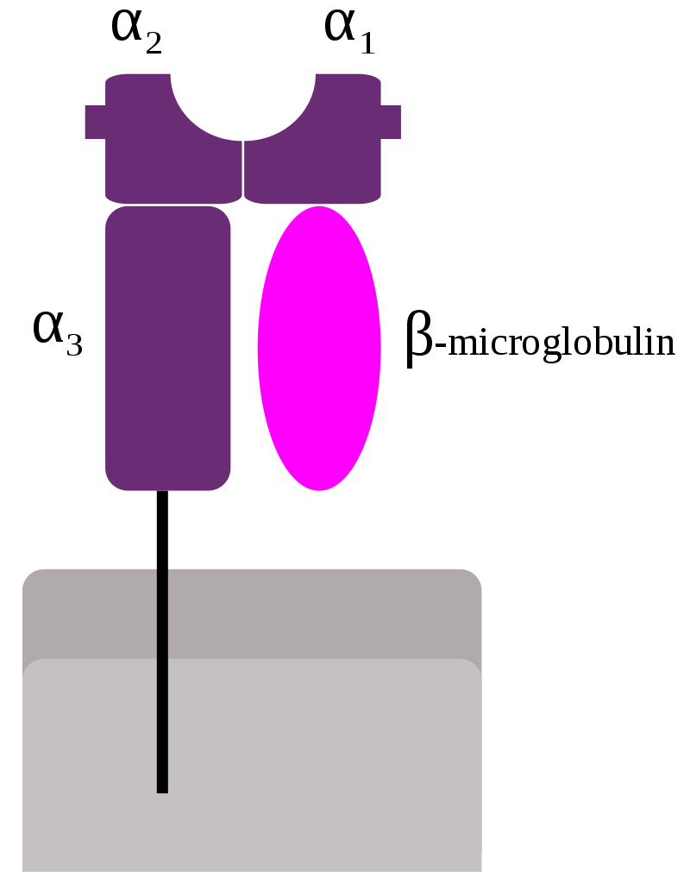
MHC class I protein molecule

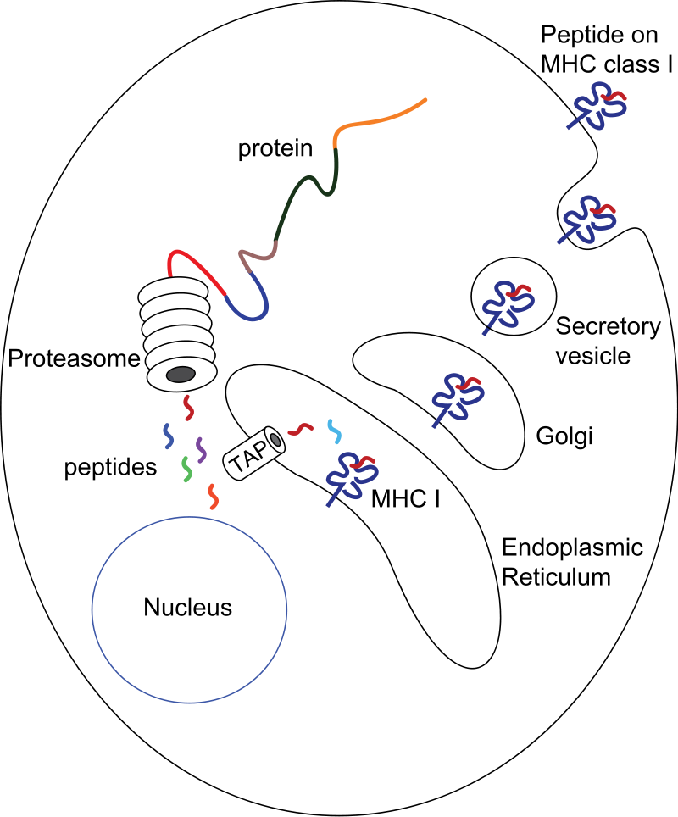

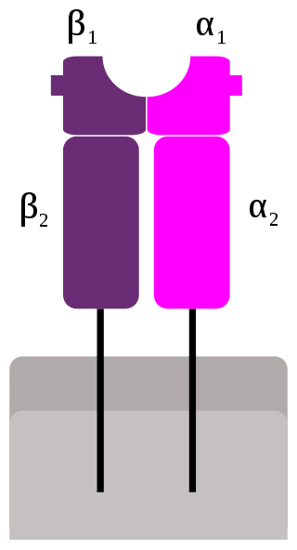
MHC class II protein molecule

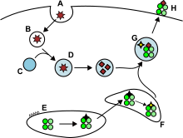
Cell mediated immune response :

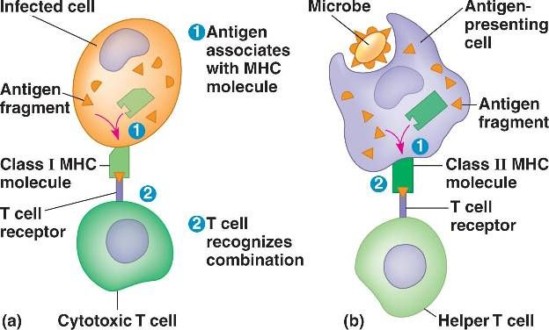

Lecture: 8 Immune Tolerance
Immune tolerance, is a state of unresponsiveness of the immune system to substances or tissue that have the capacity to elicit an immune response in given organism .It contrasts with conventional immune-mediated elimination of foreign antigens . Tolerance is classified into central tolerance or peripheral tolerance depending on where the state is originally induced in the thymus and bone marrow (central) or in other tissues and lymph nodes(peripheral). The mechanisms by which these forms of tolerance are established are distinct , but the resulting effect is similar.
Immune tolerance is important for normal physiology. Central tolerance is the main way the immune system learns to discriminate self from non-self. Peripheral tolerance is key to preventing over-reactivity of the immune system to various environmental entities (allergens, gut microbes, etc.). Deficits in central or peripheral tolerance also cause autoimmune disease, resulting in syndromes such as systemic lupus erythematosus, rheumatoid arthritis, type 1 diabetes.
Immune tolerance encompasses the range of physiological mechanisms by which the body reduces or eliminates an immune response to particular agents. It is used to describe the phenomenon underlying discrimination of self from non-self, suppressing allergic responses, allowing chronic infection instead of rejection and elimination, and preventing attack of fetuses by the maternal immune system. Typically, a change in the host, not the antigen, is implied. Though some pathogens can evolve to become less virulent in host-pathogen coevolution, tolerance does not refer to the change in the pathogen, but can be used to describe the changes in host physiology .
Central tolerance refers to the tolerance established by deleting autoreactive lymphocyte clones before they develop into fully immunocompetent cells. It occurs during lymphocyte development in the thymus and bone marrow for T and B lymphocytes, respectively. In these tissues, maturing lymphocytes are exposed to self-antigens presented by medullary thymic epithelial cells and thymic dendritic cells, or bone marrow cells. Self-antigens are present due to endogenous expression . Those lymphocytes that have receptors that bind strongly to self-antigens are removed by induction of apoptosis of the autoreactive cells, or by induction of anergy, a state of non-activity. Weakly autoreactive B cells may also remain in a state of immunological ignorance where they simply do not respond to stimulation of their B cell receptor. Some weakly self-recognizing T cells are alternatively differentiated into natural regulatory T cells (nTreg cells).
Peripheral tolerance develops after T and B cells mature and enter the peripheral tissues and lymph nodes. It is established by a number of partly overlapping mechanisms that mostly involve control at the level of T cells, especially CD4+ helper T cells, which orchestrate immune responses and give B cells the confirmatory signals they need in order to produce antibodies. Inappropriate reactivity toward normal self-antigen that was not eliminated in the thymus can occur, since the T cells that leave the thymus are relatively but not completely safe. Some will have receptors (TCRs) that can respond to self-antigens .
Lecturer : Majida G. Magtooph

